Assignment Proposal (20%)

**Group Number:** 1

**Assignment Title:** EZ INTERN

|  |  |  |  |
| --- | --- | --- | --- |
| No. | Student ID | Name | Tasks |
| 1 | 1161102437 | Muhamad Irfan Dhiyauddin Bin Mohd Hafizul | Student Profile / Supervisor Profile / Registration Form |
| 2 | 1161102149 | Ahmad Faiq Biin Ahmad Radzali | Student List / Student ITP Status / Supervisor Profile / About Us |
| 3 | 1161102372 | Muhammad Fattah Bin Sallehuddin | Logo Design / Website Theme / Navigation Bar / Company, Supervisor, Student Login / Internship List / Post New Internship |
| 4 | 1142700568 | Eric Wong Yean Hwang | Company Profile / Edit Company Profile |
| 5 | 1161102210 | Ishraf Bin Ismay | Student List/ Company List |

**Marks distribution:**

|  |  |
| --- | --- |
| Item | Marks (20%) |
| Web Application (Prototype) | 10 |
| Proposal (maximum 10 pages)  1) Introduction  2) Problem Statement  3) Objectives  4) Task division for each student  5) Solution:  i) Analysis  a) Use-case diagram  b) Requirements  ii) Design  a) Placement of elements on  page  b) Navigational flow  c) Intuitive design  iii) Implementation  a) Screenshots (maximum 2  pages ONLY) and description  of application  b) Plan for Assignment 2  6) Conclusion | 10 |

# **1.0 Introduction**

Most, if not all universities include industrial training as one of the compulsory courses for their students. Because of this, most universities have set a specific semester each year for students to partake in this subject and most of them time, the training period varies from 3 months to 6 months. Many industrial training coordinators in universities made it so that each lecturer has to be responsible as an internship supervisor for at least one student on the specified semester. Internship supervisors are responsible to manage their supervisees' welfare as well as documents submitted by the students, such as the weekly and monthly reports as well as the final report. Other than that, different companies are also always searching for potential internship students for their company. This all will be made easy by using EZ INTERN, our web application for industrial training management system.

# **2.0 Problem Statement**

Nowadays, when students are searching for companies to do their internship at, they will need to go and search for available internship placements online. This proves to be quite difficult as there are many websites that posts different internship advertisements. Next, during the internship, the students would have to send their reports to their university's internship supervisor. Most of the time, this is done by email, and this method has been proven to be quite hard to keep track of as there are a lot of other emails received by the supervisor daily. From the company's perspective, trying to find students to fill in their internship vacancy can be quite challenging as there are not many sites that provides a platform for students to advertise themselves for internship.

# **3.0 Objectives**

Design and develop a well-organized, user-friendly website, which provides quality contents and solutions for the users. EZ INTERN will surely bring maximum satisfaction to users as this platform aims to:

* Provide a place for companies to advertise their internship vacancies.
* Improve the communication between internship students and their advisors.
* Ease companies to search students for their internship programme.
* Make it easier for students to find a suitable place for their internship.

# 

# **4.0 Task division for each students**

1. Muhamad Irfan Dhiyauddin Bin Mohd Hafizul.

* Completed the designing part for three pages. First page; Student profile page, a page where the user can go and view the student’s personal information. Second page; Supervisor profile page, a page where user can go and view the student’s personal information. Third page; Registration form / Signup Page, a popup to be, where the user can go and register themselves if they haven’t registered yet for the website.

1. Ahmad Faiq bin Ahmad Radzali

* Create pages for supervisor’s point of view. The pages are; first, supervisor’s profile, where the supervisor can edit their details such as phone number and email address. Second, student listings, where a supervisor can view all students that they are currently managing. Third, student details, containing student’s brief profile, and their industrial training status. And also the generic About Us page.

1. Muhammad Fattah Bin Sallehuddin

* Designed the theme for the website, and created our official website logo as well as the navigation bar for all types of users. Designed and created all 3 different types of login pages for each user, the internship advertisement list page which posts advertisements from companies searching for an internship student, and finally the new internship post page which adds new posts to the advertisement list.

1. Eric Wong Yean Hwang

* Complete created two pages for company’s point of view. First page; Company profile page, a page which contains company’s logo and company’s information. Second page; Company Profile Edit page, a page which allow company to edit their company’s logo and company’s information via a textbox.

1. Ishraf Bin Ismay

* Create page for both student’s and company’s point of view. First page; student list page, it contains the student’s id, name, the faculty of the student and their specialization. This is where companies can view their profile. The second page; company list page, where in this page it shows the logo and the name of the company that are available for internships. Students can view a company’s profile from here.

# **5.0 Solution**

## ***5.1 Analysis***

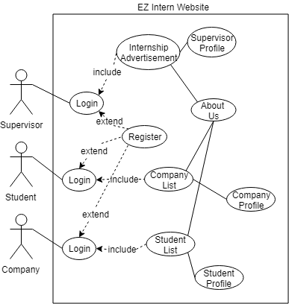

*Figure 1.0 :* *Use case diagram of the website*

***Functional Requirements:***

* The website will validate whether the account is for a student, a company or a supervisor.
* User will be directed to a specific page as their homepage.
* Only account owner can edit or update their own profile.
* Colour scheme for the navigation bar is rgb(136, 137, 139).
* Different type of account will have different navigation bar content.

***Non - Functional Requirements:***

* Every type of account can view student or company profile.

## ***5.2 Design***

As for the design, we decided to make it simple and easily understandable. Firstly, our header consist of the EZ Intern Logo on the top left, navigation bar, current time and a logout button on the top right. The website theme is mostly consist of gray, black, white, red and blue. Separating the header and the body, we used HR element which is a straight line. For the body, image is always on the left especially in the profile page. The text is mostly on the right side of the page. The text element have differences according to its purposes. Button text is mostly bold. The font type is Arial, Sans Serif. Font-size depends on the functionality and importance of each text. For example, Student’s Profile will be following Heading 2 font size. Bold text is for titles and heading while normal text is usually for informational text that can be modified its content. The footer design is the same as the header.

Next, for the navigational flow, the user will start by logging into the website. They can choose to login as a student, supervisor or company. If they login as a student, they will be navigated to the student’s profile page. From there, the user can choose to view their supervisor or check with their companies. If they login as a supervisor, the user will be redirected to the student’s listing page. If they login as company, straightaway go to company’s profile. Logout button will make them go to the homepage which is the login page.

Lastly, the intuitive design which allows users to easily navigate through the website. As an example, the user will always know that they have to firstly, login. Then, after they have been redirected to their profile page, there is an option to go from there as an example, in Student’s Profile, there are option which allows them to view their supervisor. Then in the supervisor page there are options for the students to submit their reports.

## ***5.3 Implementation***

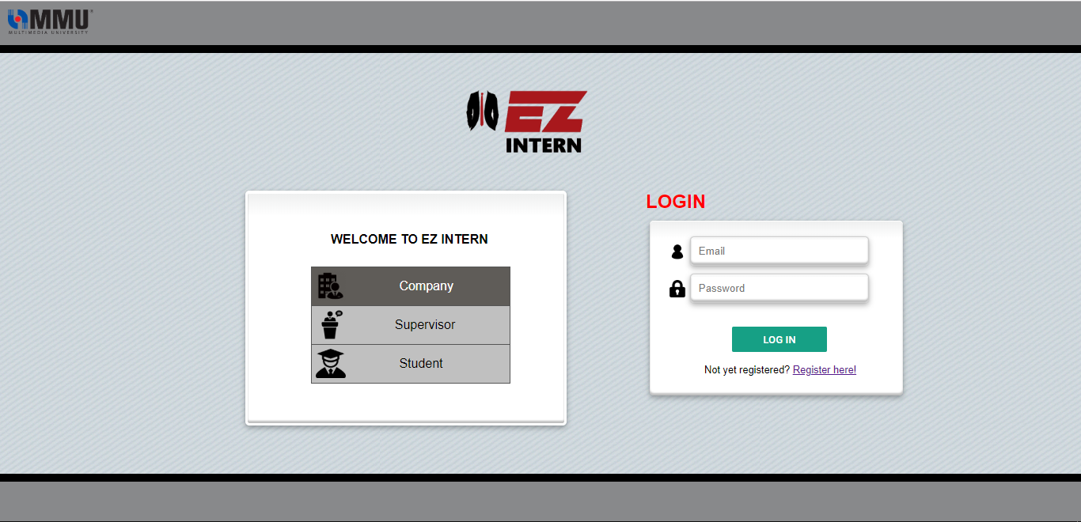

***Figure 2.0 : Login page***

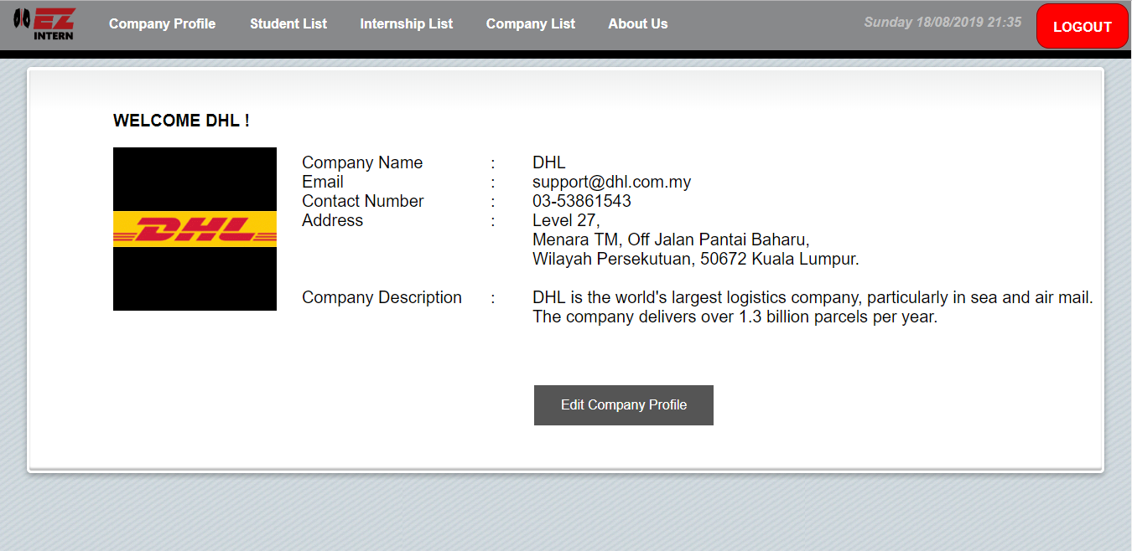

***Figure 2.1 : Company Profile page***

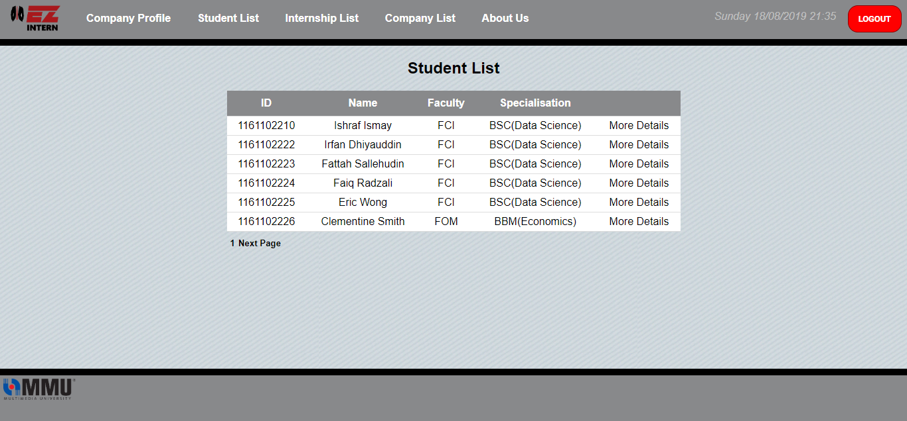

***Figure 2.2 : Student List***

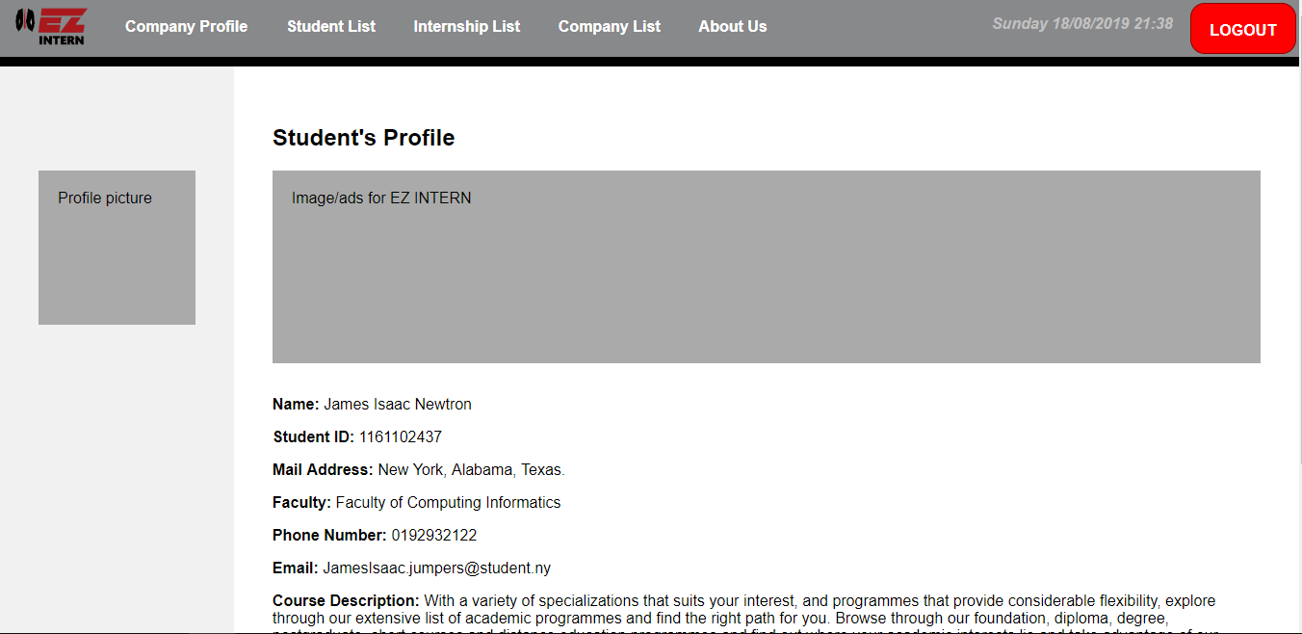

***Figure 2.3 : Student’s Profile page***

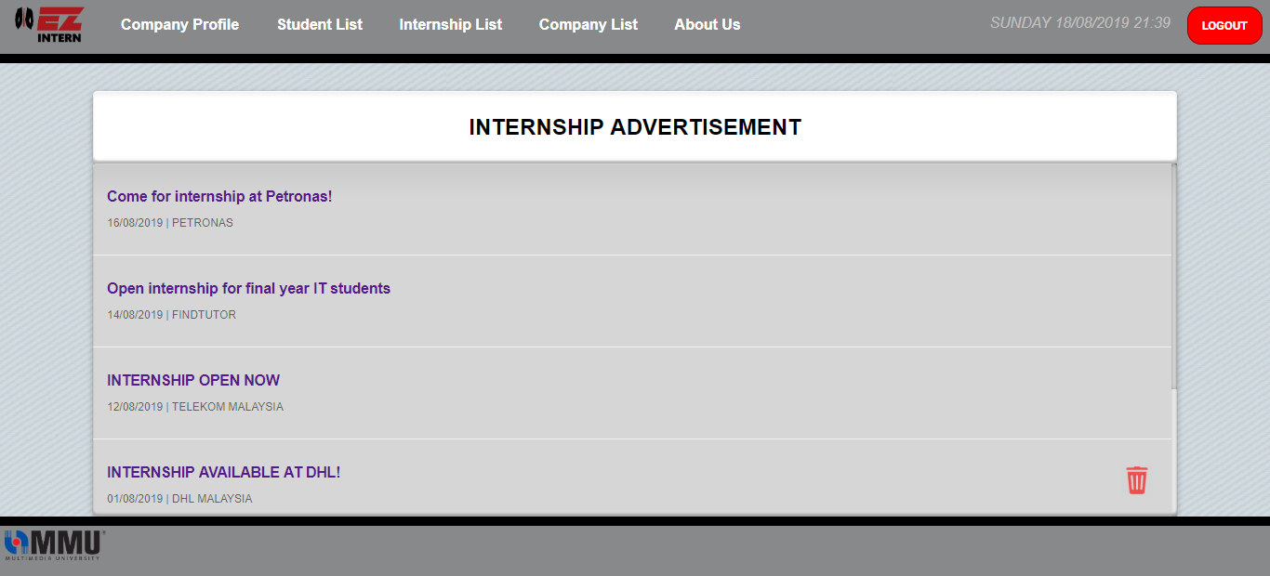

***Figure 2.4 : Internship Ads page***

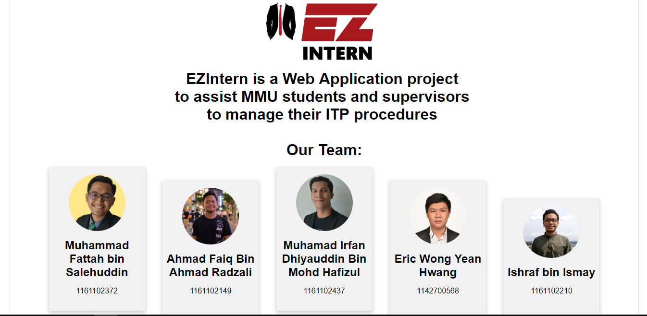

***Figure 2.5 : About us page***

***5.3.1 Plan for Assignment 2***

For the first part, we have done the website’s overall design and function for three different users. In the future, we plan to further improve our website design by adding pop-ups and other functions using Javascript on the client-side, as well as improving some parts of the HTML and CSS, after hearing some feedback from our friends.

Next, we will design a database for our website, storing the data for all three users as well as other relevant information. For this, we will be using the SQL language, a language used by many to create a database.

Not only that, we will also be using PHP to create server-side scripts in order to interact with the database storing every user info, so that the register and login page will function accordingly. Other than that, we’ll also be using PHP to add function to our “submit” buttons, so that they can interact with the back-end side of the site.

# **6.0 Conclusion**

EZ INTERN is created to ease the workflow for students, lecturers as well as companies for matters regarding internship programme. As such, we implemented various functions into our website to achieve this. Some of them are allowing companies to advertise their internship vacancies and allow company to add their company information for students to view. Thus, this would help students to find a suitable company for their industrial training by showing company list and company details to the student. Besides, this would also improve communication between internship students and their advisor. Other than that, we added functions that allow supervisors to check on their supervisees’ information as well as keeping track on documents submitted by them. In conclusion, we strongly believe that EZ INTERN would ease the process of internship programme for students and lecturers of MMU alike.